**LAB-SHEET 3**

**DBMS**

**Name : Anuvind M P**

**Roll no : AM.EN.U4AIE22010**

1.

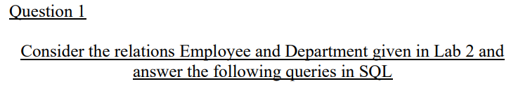

**DEPARTMENT**

--create table department(dept_no int primary key,dname varchar(14) NOT NULL,loc varchar(20));

--insert into department values(10,'accounting','new york'),(20,'research','dallas'),(30,'sales','chicago'),(40,'operations','boston');

**EMPLOYEE**

--create table employee(empno int primary key,

-- ename varchar(20) not null,

-- job varchar(10),

-- mgr_id int,

-- hired_date date,

-- basic_sal numeric(6,2) default(1000),

-- incentive numeric(6,2) check(incentive < basic_sal),

-- deptno int references department(dept_no));

-- INSERT INTO employee VALUES

-- (7369, 'smith', 'clerk', 7902, '1980-12-17', 6800, NULL, 20),

-- (7499, 'allen', 'salesman', 7698, '1981-02-20', 1160, 300, 30),

-- (7521, 'ward', 'salesman', 7698, '1981-02-22', 1125, 500, 30),

-- (7566, 'jones', 'manager', 7839, '1981-04-02', 2297, NULL, 20),

-- (7654, 'Martin', 'salesman', 7698, '1981-09-28', 1125, 1124, 30),

-- (7698, 'blake', 'manager', 7839, '1981-05-01', 2285, NULL, 30),

-- (7782, 'clark', 'manager', 7839, '1981-06-09', 2245, NULL, 10),

-- (7788, 'scott', 'analyst', 7566, '1982-12-09', 1300, NULL, 20);

1.Create a table Department_locn with fields deptno and location where both are its primary keys and deptno references Department table.

create table Department_loc(dept_no int references department(dept_no),

location varchar,

primary key(dept_no,location));

2.Change the empno of the employee whose name is ‘Meena’.

INSERT INTO employee VALUES(7333, 'meenu', 'clerk', 7999, '1980-12-16', 6810, NULL, 30);

update employee

set empno=7334

where ename='Meena';

3.Drop the column DOB from Employee.

ALTER TABLE Employee

DROP COLUMN hired_date;

4.Retrieve information of departments with deptno 1, 4, 8

select * from department where dept_no in(10,20,30);

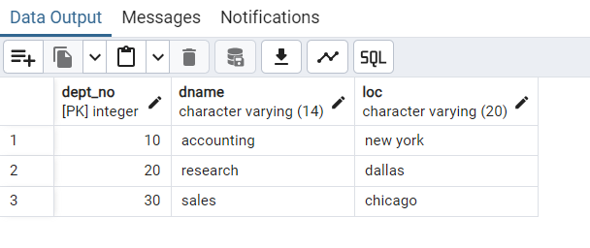

5.Show the different salaries of employees eliminating duplicate values.

select distinct basic_sal from employee;

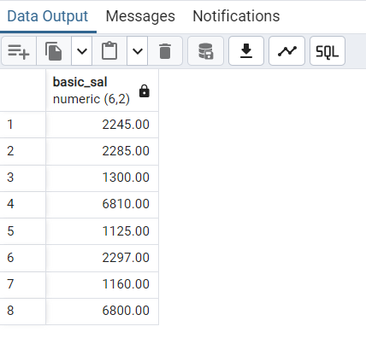

6.Show details of the department sorted by department number.

select * from department order by dept_no;

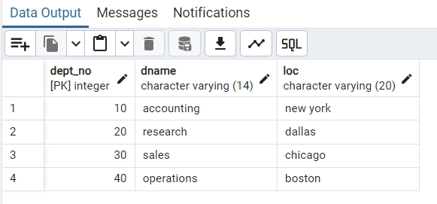

7.Create a table emp having three fields empno, empname and salary from the source table employee . The table emp should not have any records.

CREATE TABLE emp AS

SELECT empno, ename, basic_sal

FROM employee

WHERE 1 = 0;

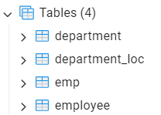

8.Insert data into emp using employee as the source of data.

INSERT INTO emp (empno, ename, basic_sal)

SELECT empno, ename, basic_sal

FROM employee;

9.Add a column joindate to employee table.

alter table employee

add joining_date date;

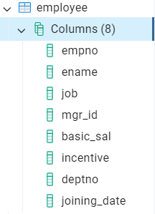

10. Drop primary key from department.

alter table department

drop constraint department_pkey;

11.Display names of employees whose name begins with ‘m’ and has 2 ‘e’s

select ename from employee where ename like 'm%e%e%';

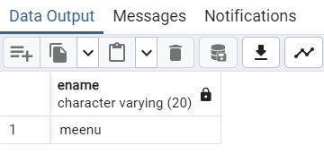

12. Display names of employees whose name begins with ‘m’ and salary > 10000.

select ename from employee where ename like 'M%' or ename like 'm%' and basic_sal>1000;

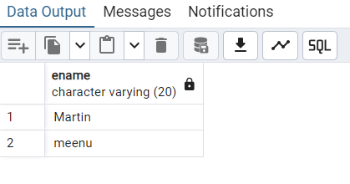

13. Give the number of employees whose salary is greater than 2000.

select count(empno) from employee where basic_sal>2000;

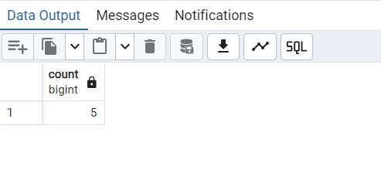

14. Arrange the employees by their department numbers.

select * from employee order by deptno;

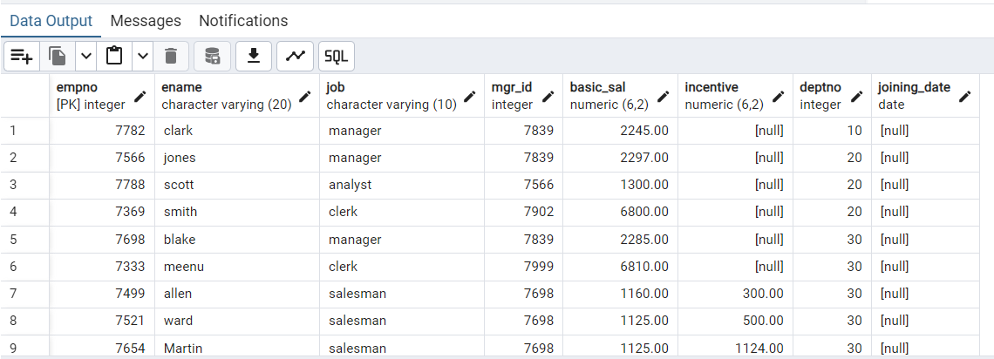

15. Display the department number along with number of employees in each department.

select deptno,count(empno) from employee group by deptno;

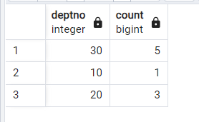

16. Find the departments having more than 10 employees.

select deptno,count(empno) from employee group by deptno having count(empno)>3;

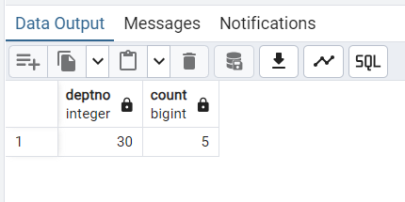

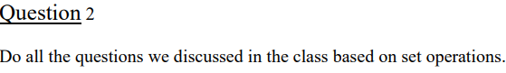

--create table customer(cno int primary key,cname varchar(30),ctype varchar(10) );

--create table cust_fd(cno int references customer(cno),fd_no int primary key,fd_amt numeric(50),int_rate numeric(50));

--create table cust_loan(cno int references customer(cno),ln_no int primary key,ln_type varchar,ln_amt numeric);

--create table emp_details(cno int references customer(cno),ename varchar,sal numeric,br_no int);

--create table account(acc_no int primary key,cno int references customer(cno),veri_emp_no int,acc_type varchar );

-- INSERT INTO customer (cno, cname, ctype) VALUES

-- (1, 'John Doe', 'Premium'),

-- (2, 'Jane Smith', 'Basic'),

-- (3, 'Alice Johnson', 'Premium'),

-- (4, 'Bob Brown', 'Basic'),

-- (5, 'Charlie Adams', 'Premium'),

-- (6, 'Diana Clark', 'Basic'),

-- (7, 'Evan Taylor', 'Premium'),

-- (8, 'Fiona Lewis', 'Basic'),

-- (9, 'George Martin', 'Premium'),

-- (10, 'Hannah Scott', 'Basic');

-- INSERT INTO cust_fd (cno, fd_no, fd_amt, int_rate) VALUES

-- (1, 1001, 50000, 4.5),

-- (2, 1002, 75000, 5.0),

-- (3, 1003, 60000, 4.8),

-- (4, 1004, 80000, 5.2),

-- (5, 1005, 55000, 4.7),

-- (6, 1006, 45000, 5.1),

-- (7, 1007, 95000, 4.9),

-- (8, 1008, 105000, 5.3),

-- (9, 1009, 62000, 4.6),

-- (10, 1010, 78000, 5.4);

-- INSERT INTO cust_loan (cno, ln_no, ln_type, ln_amt) VALUES

-- (1, 2001, 'Home Loan', 250000),

-- (2, 2002, 'Personal Loan', 50000),

-- (3, 2003, 'Car Loan', 120000),

-- (4, 2004, 'Education Loan', 30000),

-- (5, 2005, 'Home Loan', 270000),

-- (6, 2006, 'Car Loan', 150000),

-- (7, 2007, 'Personal Loan', 80000),

-- (8, 2008, 'Business Loan', 500000),

-- (9, 2009, 'Education Loan', 45000),

-- (10, 2010, 'Personal Loan', 100000);

-- INSERT INTO emp_details (cno, ename, sal, br_no) VALUES

-- (1, 'Mark Spencer', 55000, 101),

-- (2, 'Lucy Martin', 60000, 102),

-- (3, 'John David', 52000, 103),

-- (4, 'Emily White', 58000, 104),

-- (5, 'Michael James', 61000, 105),

-- (6, 'Sophia King', 54000, 106),

-- (7, 'Oliver Green', 57000, 107),

-- (8, 'Amelia Turner', 62000, 108),

-- (9, 'Mason Lee', 51000, 109),

-- (10, 'Isabella Wright', 53000, 110);

-- INSERT INTO account (acc_no, cno, veri_emp_no, acc_type) VALUES

-- (3001, 1, 1, 'Savings'),

-- (3002, 2, 2, 'Current'),

-- (3003, 3, 3, 'Savings'),

-- (3004, 4, 4, 'Current'),

-- (3005, 5, 5, 'Savings'),

-- (3006, 6, 6, 'Current'),

-- (3007, 7, 7, 'Savings'),

-- (3008, 8, 8, 'Current'),

-- (3009, 9, 9, 'Savings'),

-- (3010, 10, 10, 'Current');

**--a)List the customer number of those customers who have got both**

**--loan and fd at the bank**

--select cno from cust_fd intersect select cno from cust_loan;

**--b)List the customer number of those customers who have got either**

**--loan or fd at the bank**

--select cno from cust_fd union select cno from cust_loan;

**--c)List the customer number of those customers who have got FD**

**--but not loan at the bank**

-- Insert customer details for those who have FD but no loan

--INSERT INTO customer (cno, cname, ctype) VALUES

-- (11, 'Ivy Cole', 'Premium'),

-- (12, 'Jackie Ford', 'Basic'),

-- (13, 'Kyle Evans', 'Premium');

-- Insert customers with FD but no loan

-- Assume customer numbers 11, 12, and 13 have FD but no loan

--INSERT INTO cust_fd (cno, fd_no, fd_amt, int_rate) VALUES

-- (11, 1011, 85000, 4.6),

-- (12, 1012, 70000, 4.8),

-- (13, 1013, 92000, 5.1);

--select cno from cust_fd except select cno from cust_loan;

**OUTPUTS**

**INTERSECT**

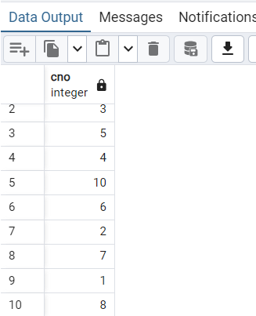

**UNION**

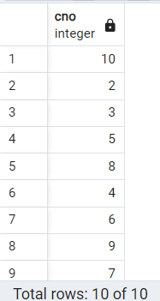

**EXCEPT**

